**Ahmer Aziz 4124**

[**https://www.demoblaze.com/**](https://www.demoblaze.com/)

**Index Page:**

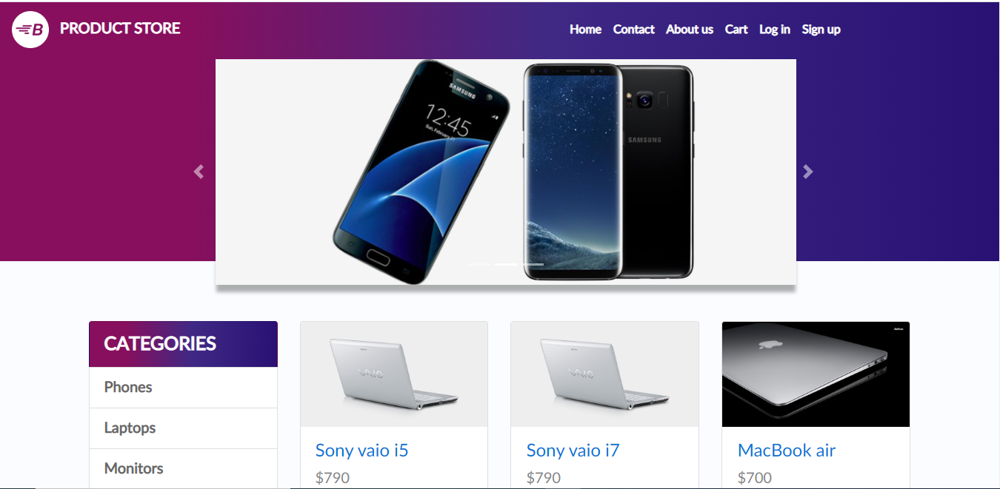

* Home button redirect to index page.

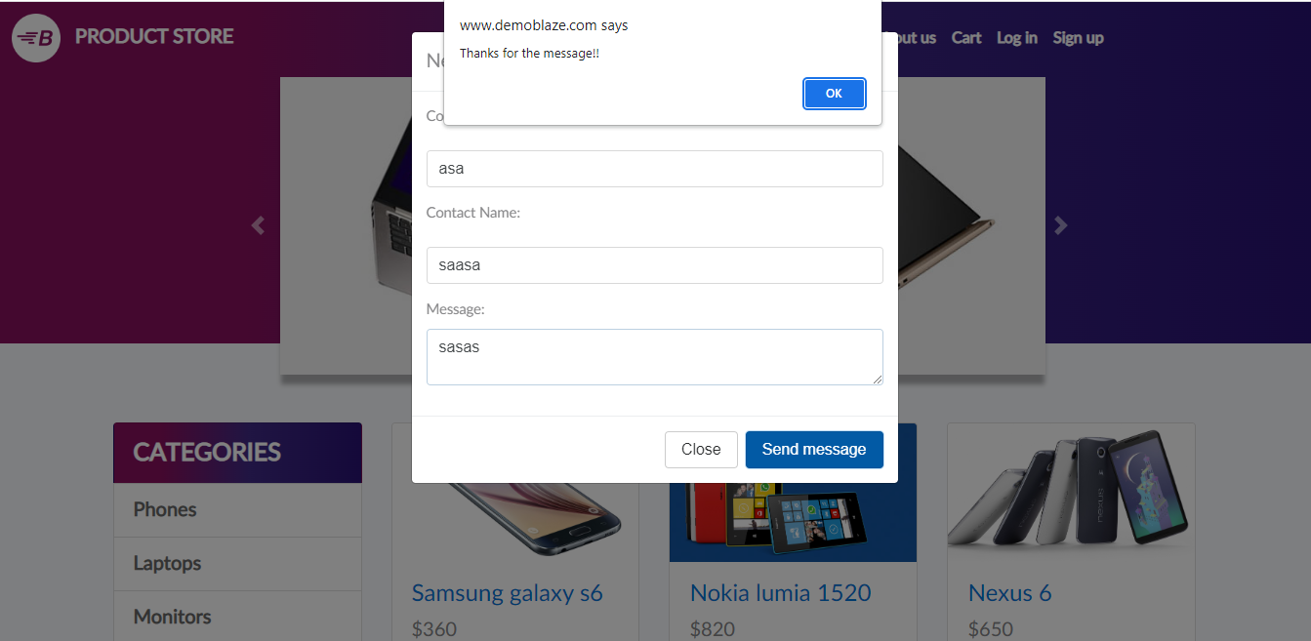

* Contact US button, when click a window pop up with email, name and message field.
* When field are filled with detail and submit button click another alert open and show message.

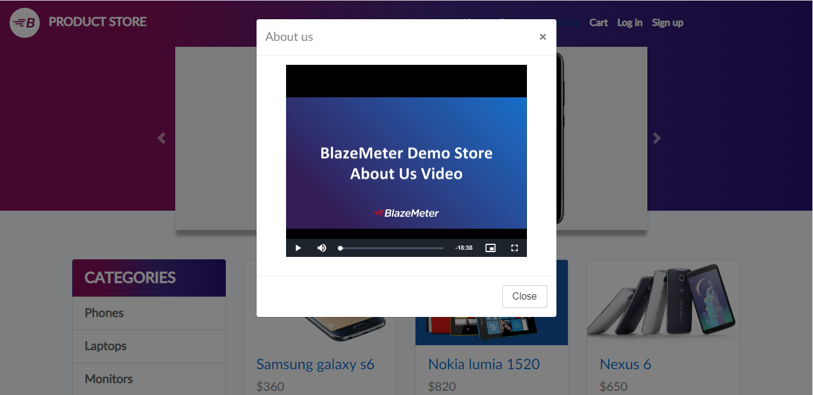

* When click in about us button a window with video pop up.
* A button is place on the top left corner of the page. On click the video of 18 mint resume.
* There is a close button on the bottom right corner of the pop up window and a cross button on the top left corner of the window.

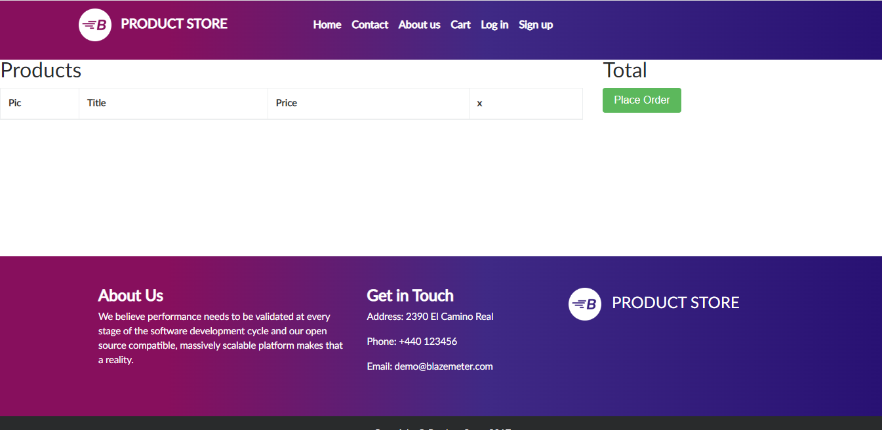

* When click on cart another page with cart open where the items are place when ordered.
* Order can be can cancelled when click on cross button.

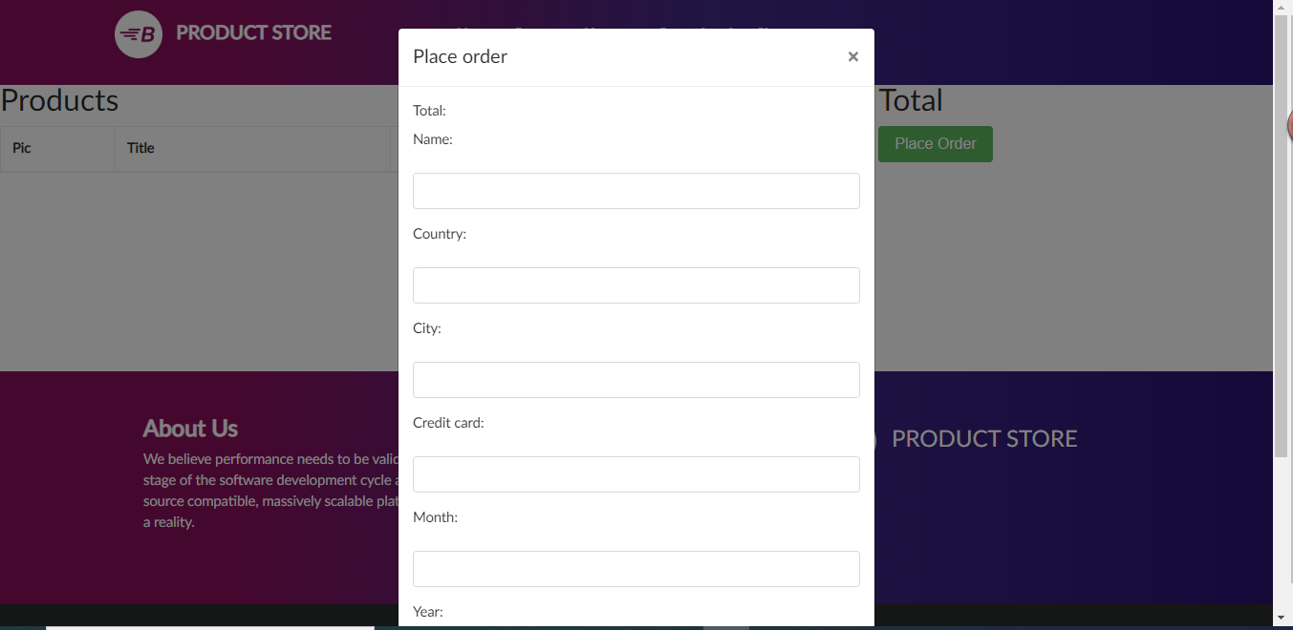

* When click on Place Order pop window will open with text field.
* Detail can be entered on text field.
* After filling the form, we can purchase order on cart or we can cancel them

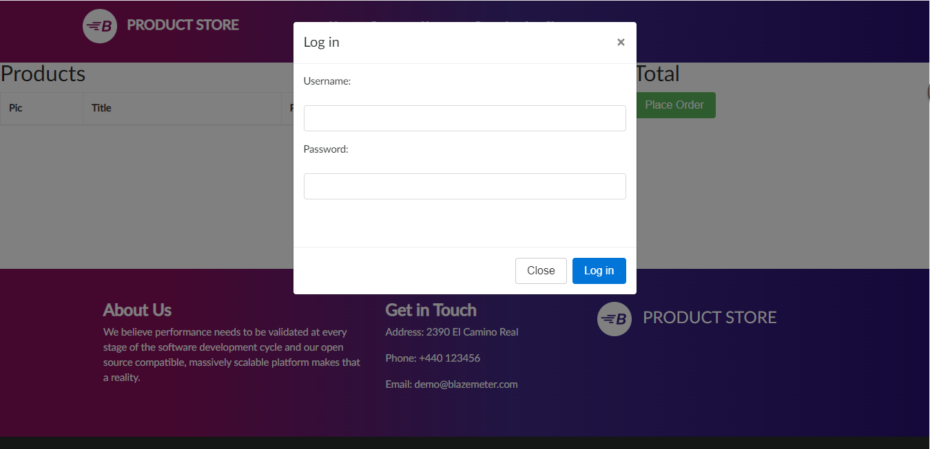

* When click on login button on index page pop up window open and user can sign in with username and password.
* User can cancel at any time when close button clicks.
* After filling the field user can login to website.



* When click on Sign Up button on index page pop up window open and user can sign up with username and password.
* User can cancel at any time when close button clicks.
* After filling the field user can sign up to website.

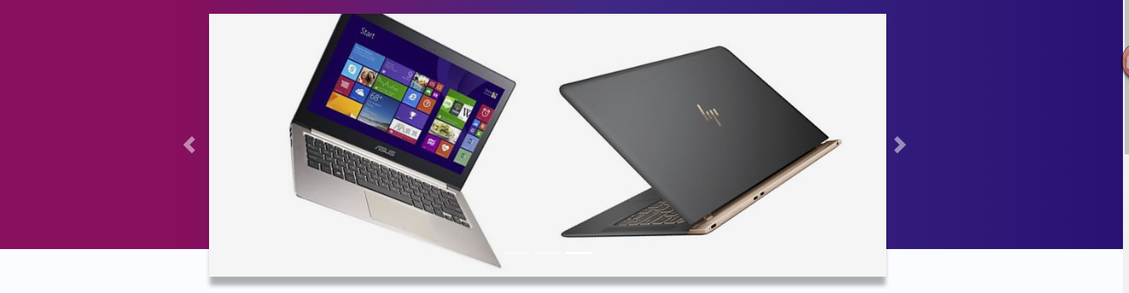

* User can slide images on slider using the left right button.

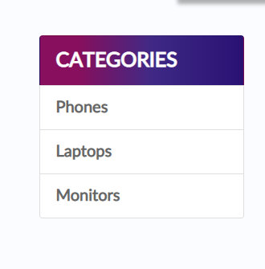

* User can select the categories on the demoblaze.com website.
* There are 3 categories: phones, laptops monitors.

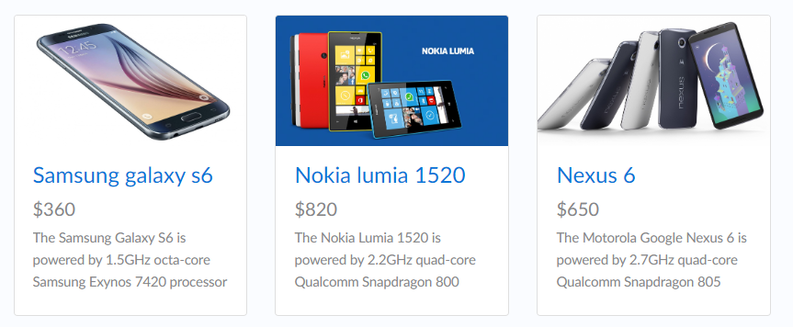

* When click on card it will redirect to a new page where we can place order according to category.

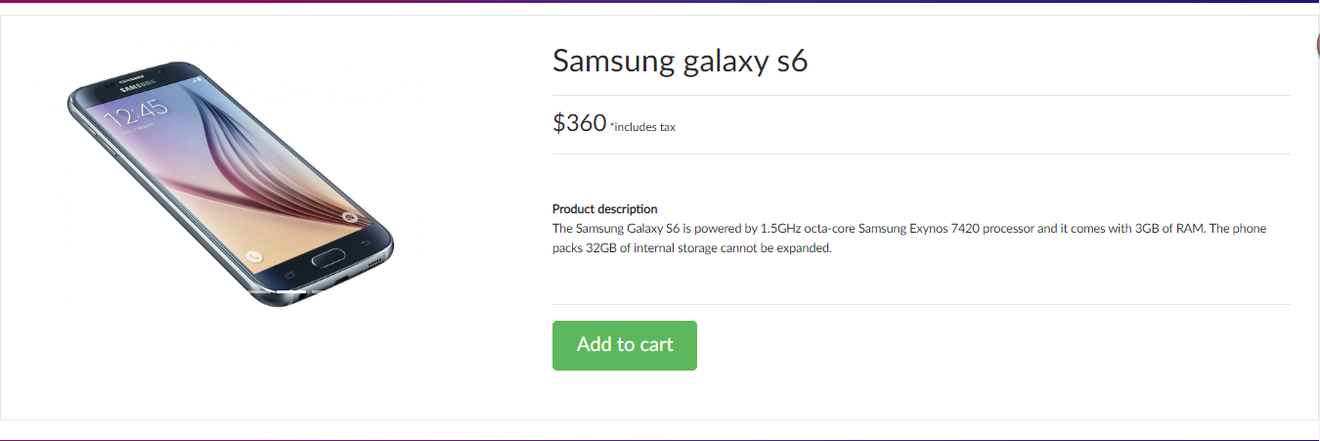

* After clicking on the card the category can be added to the cart where we can place order or we can cancel the order.



* With the help of previous and next user can navigate to different pages on the demoblaze.com website.